游乐场（荒野之国）
路程：5公里，15分钟。地点：丽江北

Luna Park Scout Recap

- 2 Big sets

Set # 1:
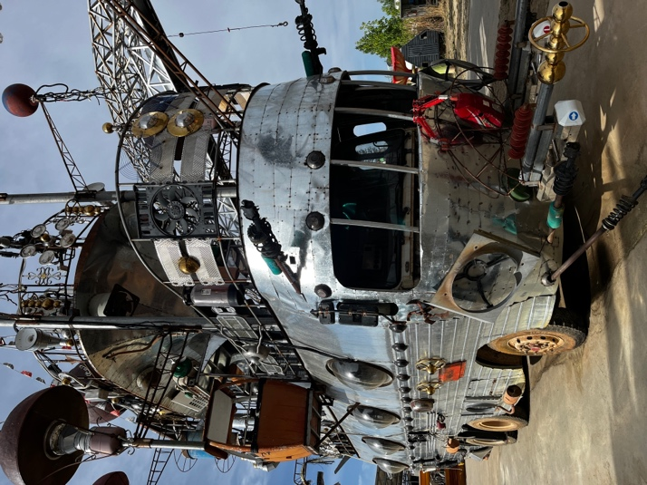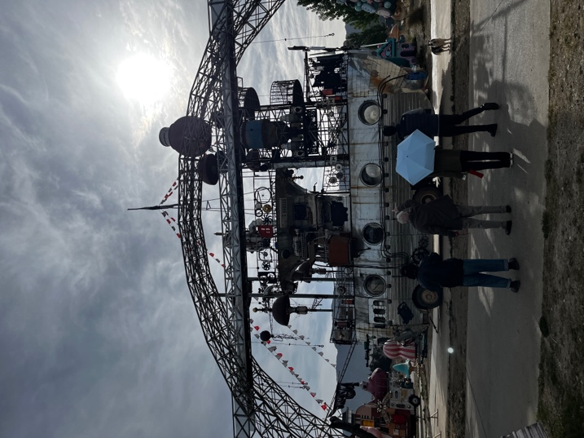

Here we would add a slide, put a bubble pond at bottom
Kid extras inside the boat, sliding down a slide (number of kids tbd)

Or Big set #2:
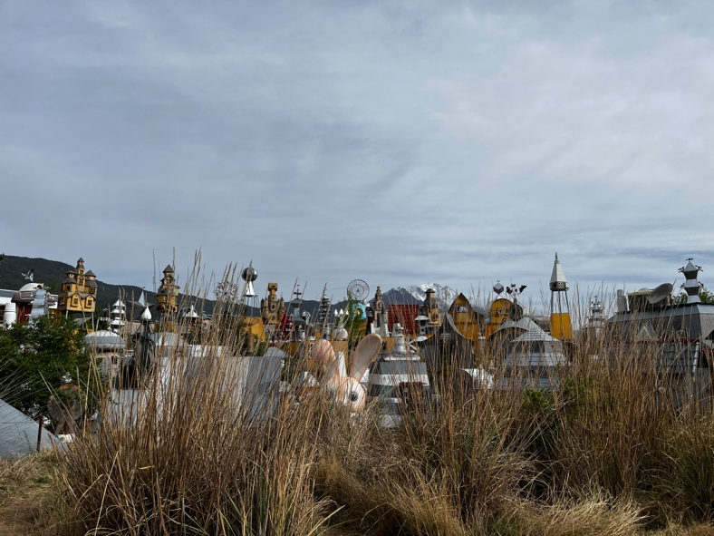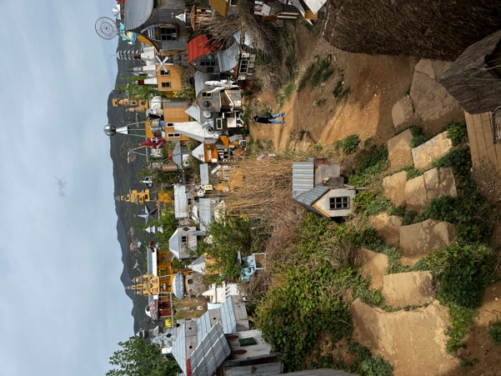

Set #2 – A playful moment between mom and daughter:

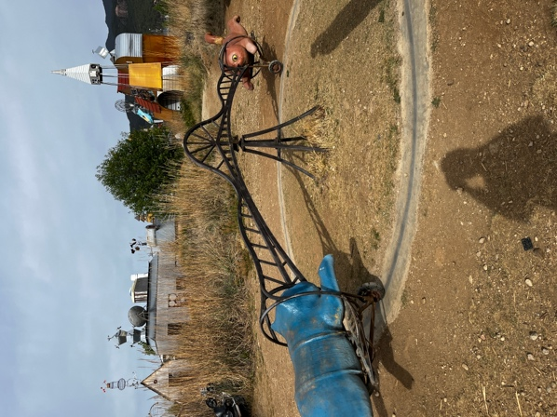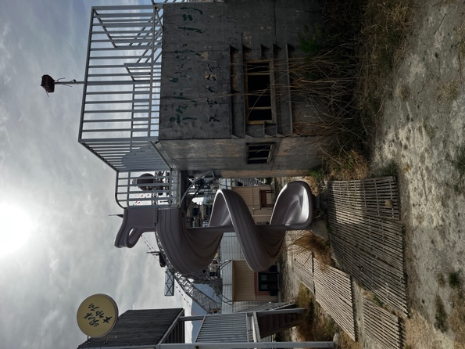
At going around game And or at slide game

Set #3 XiaoYu goes driving “like her mom” in one of the vehicles.
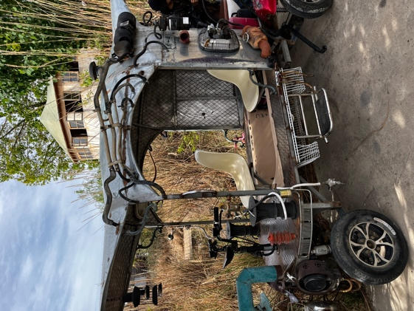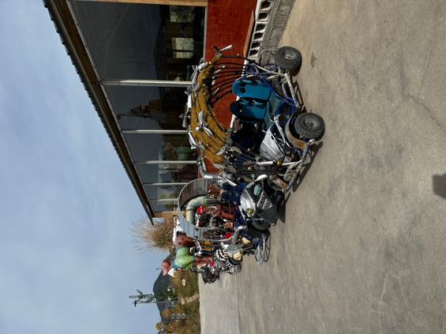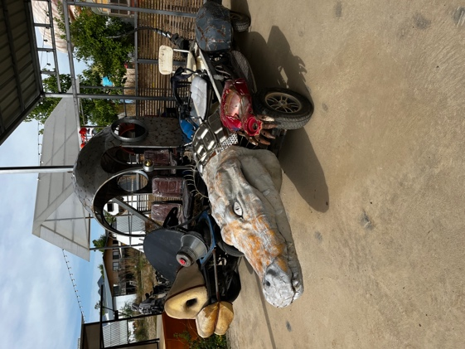
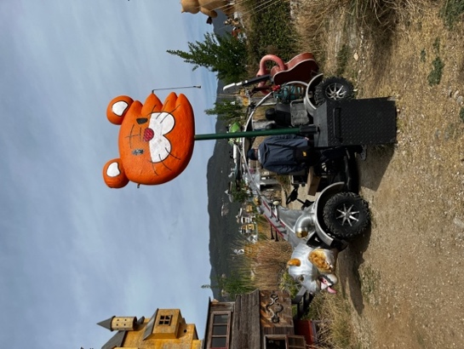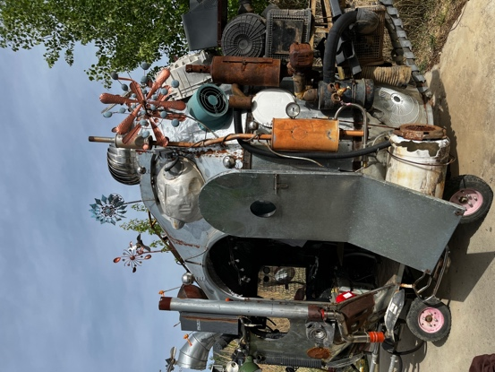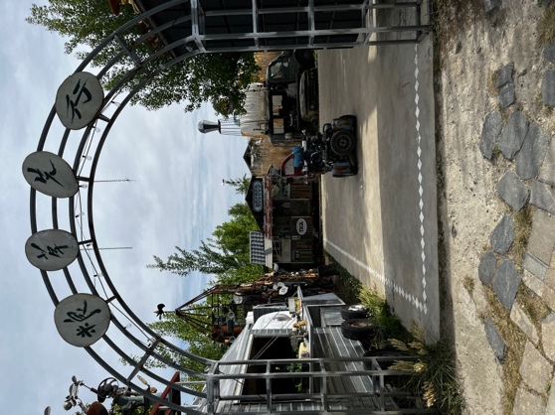
Props to pick one in functioning order. Or ask to be fixed.

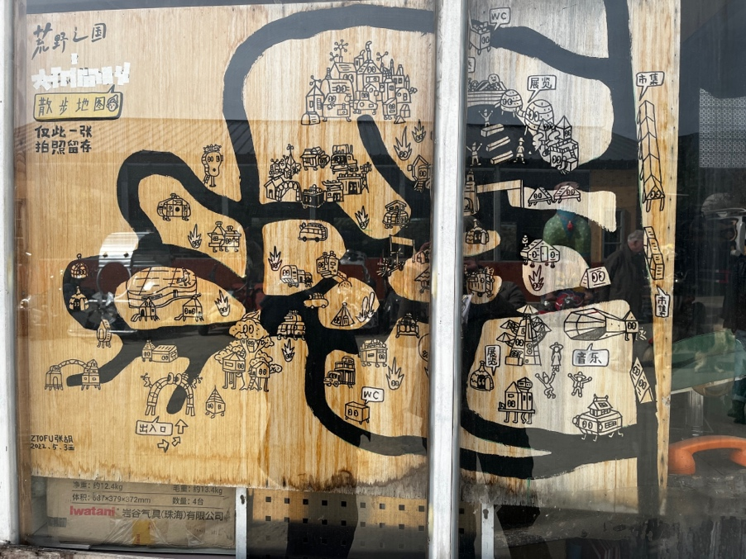
Map of Grounds

Set # 4 for scene 105
英子在卡车里收到星星玩偶，将其挂在后视镜上。随后她查看手机消息，内容是她与女儿关于家庭成员的温馨对话，女儿表达了对家人的爱和看法。
Yingzi receives star-shaped dolls in her truck and hangs one on the rearview mirror. She then checks her phone, reading a heartfelt text exchange with her daughter about family members, where the child shares her love and perspectives.

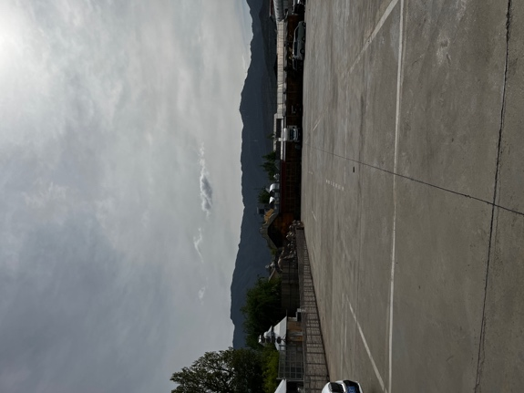

- AD to scehdule 2nd unit guy to come here end of day —- catch details of the various games

